Colorado Online @
Learning Design Committee Recommendation Deliverable 3 – Document process for designing ready-to-teach courses in collaboration with state discipline groups, including selection of course/instructional materials.
5-27-2022

Contents
Contents 1
Introduction 2
DELIVERABLE 3: Collaborative Learning Design Process 3
Recommendations 4
Rationale 5
Factors to Consider 6
Potential Impact/Effect on Other Decisions 7
Required Resources 7
Next Steps 8
Communication Plan 8

Introduction
As part of the transition to the consortial model for Colorado Online @, the Learning Design Subcommittee was asked to document a process for designing Ready-to-Teach (RtT) courses in collaboration with state discipline groups, including selection of course/instructional materials.
Our deliverable team members represent large and small colleges, and are a mix of faculty, administrators, and learning design staff. We assembled and began our work in September 2021.
Deliverable 3 Work Group Team Members:
- Grace Whiteaker: CCCOnline | Learning Designer | Work Group Lead
- Nancy Denton: PCC | Instructional Designer​
- Janiece Kneppe Walter: RRCC | Faculty
- Peter Lindstrom: CCD | Math ENG/1st Gen Dean​
- Kae Novak: FRCC | Assistant Director, Learning Design
- Kai Savi: CCCOnline | Associate Dean, Sciences​
- Robin Schofield: PPCC | Associate Professor Director​
- Jacqueline Tomrdle: PPCC | eLearning Coordinator
Learning Design Sub-Committee Members:
- Stephanie Wickman: Co-Chair, FRCC, Director, Learning Design and Technology
- Tina Parscal: Co-Chair, CCCS, Associate Vice Chancellor for CCCOnline and Academic Affairs
- Amanda Hardman: CCCS, Learning Designer
- Dolly Rosenbrook: FRCC, Faculty
- Grace Whiteaker: CCCS, Learning Designer
- Janiece Kneppe: RRCC, Faculty
- Julie Kotalik: TSC, Faculty
- Kelly O'Dell: CCA, Faculty
- Laylonda Maines: Various Colleges, Instructor; FRCC, Learning Design
- Veronica Koehn: NJC, Director of Academic Excellence
- Peter Lindstrom: CCD, Math, ENG/1st Generation Dean
- Robin Schofield: PPCC, Associate Professor, Director

DELIVERABLE 3: Collaborative Learning Design Process
Document process for designing Ready-to-Teach (RtT) courses in collaboration with state discipline groups, including selection of course/instructional materials.
Work on this recommendation began with an internal review of current course development processes across CCCS colleges. Through this process, we discovered that the larger colleges had the resources and formal design teams to help faculty as they built out their own courses, but only the largest colleges had the resources to dedicate instructional designers directly to the development of a course.
Early iterations of a learning design process were lacking the full measure of state-wide collaboration until the concept of a learning design academy surfaced in early-November. By mid-November, we had a strong working draft of a process to pilot and generate 7 RtT courses from two disciplines: ECE and SPA.
In January 2022 we began a two-pronged effort to update stakeholders on the process and initiate the pilot. During January and February, the working group hosted a series of roadshows to update and collect feedback with the following stakeholder groups:
- Online Faculty and Instructor Advisory Committee (OFIAC)
- Vice Presidents of Academic Affairs (VPAA)
- State Faculty Advisory Council (SFAC)
- Colorado Online @ Spring Mini-Conference (open to all Faculty and Instructors)
Overall feedback has been very agreeable, with many respondents providing additional information regarding their responses that helped to shape supporting materials and subprocesses.

Recommendations
- Recommendation 1: Adoption of the 6-phase collaborative learning design process for testing and continuous improvement, including:
  - A Learning Design Academy approach integrating collaboration to curate resources, preparation for course development, and exposure to key elements of the learning design process including the Colorado Online @ course quality standards.
  - Discipline feedback and approval on the Course Map and the final RtT course shell.
  - Stipend compensation for all faculty/instructor representatives taking part in the Academy and development phases.
Colorado Online @ Collaborative Learning Design Process: 10,000-foot view
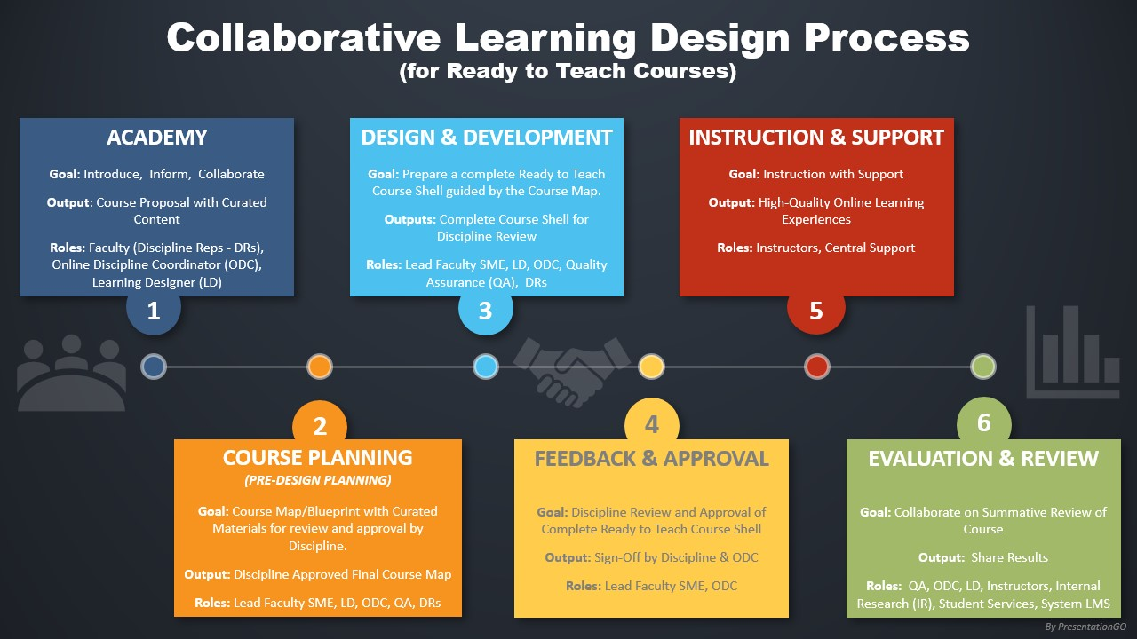
Video: Overview of the Collaborative Learning Design Process and Fall 2022 Pilot (16 min)
Detailed Flowchart: Colorado Online @ Collaborative Learning Design Process
FAQs: Colorado Online @ Collaborative Learning Design Process FAQs

- Recommendation 2: Creation of the Online Discipline Coordinator (ODC) role.
  - This role coordinates with the State Discipline Chair and will work with the discipline and the development team to facilitate communication and coordinate content-related tasks.
  - This role will assemble interested faculty subject matter experts, identify a lead Subject Matter Expert, and be the primary point of contact for discipline representatives going into Phase 1.
  - This role is compensated for their work within the development cycle.
  - Assumption: Online Discipline Coordinators (ODCs) will go through onboarding and training prior to their first Academy formation to become familiar with the responsibilities within the design process, to uphold best practices for online learning, and to be familiar with accessibility standards, UDL, and DEI concepts related to providing the best student experiences.

Rationale
This recommendation supports collaboration in the curation, design, development, review, and approval process of the RtT course shells. This process will include interested faculty and the State Discipline Chair (possibly serving as the Online Discipline Coordinator role) as well as other members of the discipline.
The Learning Design Process Workgroup developed these recommendations to achieve the following:
- Enhance collaboration and consensus across the system by:
  - Bringing discipline peers from colleges around the system together to collaborate on content curation while socializing the standards that make a quality course and informing about relevant topics and parts of the process.
  - Curating the "best" elements of typically existing courses into a course proposal to direct the path that the lead SME will use to develop the (RtT) course.
  - Providing a structured forum to talk about online learning in an intentional and purposeful manner.
- Foster equitable access to design and development resources for online learning:
  - There are uneven resources to support online course design/ learning design due to individual college budget constraints and prioritizations.
  - There is uneven support for offering online learning due to individual college staffing constraints and prioritizations.
  - Providing RtT versions of courses would provide access to quality resources for all colleges and students.
- Provide quality online courses to instructors, faculty, and students:
  - The RtT course shell provides a fully developed course to run as-is or to customize as needed to all faculty, but especially for instructors who have been hired to teach, not necessarily design and develop.
  - The RtT course shells are designed to provide a quality student experience by meeting all course quality standards related to accessibility, DEI (diversity, equity, and inclusion), and learner-centered design.

Factors to Consider
There will be an increased workload for learning design services as well as additional demands on the State Discipline Chair, a volunteer, 1-year position. While current staffing levels at larger colleges may be able to absorb this support, some colleges may not. In support of the entire system of colleges, the Learning Design Process Workgroup developed both the learning design academy space, and created and recommends the role of an Online Discipline Coordinator during development to serve as a proxy to the State Discipline Chair for the Colorado Online @ course and program development of RtT course shells.
Benefits
- Faculty peers collaborate and curate together to bring the best to each course. Contributions to the course design come from across the system and the RtT course is approved by the discipline.
- Online Discipline Coordinators are faculty peers from within the system with experience related to the discipline and the needs of online course design, development, and delivery.
- Equitable access to fully developed online courses meeting course quality standards.
  - Smaller colleges have access to course content and learning design resources for online courses.
  - New hires have access to a fully accessible, developed course, which meets quality standards.
  - Faculty and instructors can choose to use and customize a fully accessible, developed course for their needs.
Challenges
- Larger colleges with more resources may not consider how their contributions can support the system as a whole when they can make use of their own design resources.
  - This challenge can also be considered a benefit if these colleges were to promote a prospective online course shell that meets standards and make it available for review and approval by the entire discipline as a RtT shell.
- Debate and faculty/instructor capacity within some disciplines may slow down or even halt getting to consensus for design of RtT shells.
- Additional staffing may be needed beyond the development process to support Colorado Online @ RtT course.
  - The ongoing maintenance and review of RtT courses outside of the development cycle warrants ongoing, stable oversight to coordinate with the discipline about updates and improvements.

Potential Impact/Effect on Other Decisions
These recommendations support the following:
- RtT course shells will be developed and available in the approved single D2L instance for faculty and adjuncts to review and copy for customization.
- Support of instructors using any parts of the RtT is a part of the approved 3-tier support model and centralized ticket system.
- Content curation and development within the learning design process will utilize the approved central library, OER resources, and support.
- Course development will incorporate a narrative and instructions related to the approved common navigation, home page, and content structure.
- Course development will follow the Colorado Online @ course standards adopted by the system and follow accessibility, UDL, DEI, and learner-centered design elements with the course design.
- Syllabus components in each RtT course will be built into the future syllabus management tool, if funded and deployed, with each college and the system able to place their requirements at the appropriate level within the syllabus tool.

Required Resources
- Online Discipline Coordinator (ODC) and faculty Subject Matter Expert (SME) roles, compensated per development cycle by stipend, contract, or course release.
- Stipends for Academy participants.
- Development of Standards (QM+) training (Healthy Course Checklist)
- Development of self-access training resources such as “Just-In-Time Access Aids” and “User Video Walkthroughs” will need to be developed.

Next Steps
- Pilot/Process stress test for two consecutive semesters (in progress)
- Academic Affairs will prioritize courses and programs for future development cycles to roll into the collaborative Learning Design Process.
- Request funding for Academy member stipends.
- Determine funding scheme for ODC compensation during development cycles.
- Adopt a prospect review and approval process for disciplines who are proposing an existing online course shell and can demonstrate that it meets or can be easily modified to meet Colorado Online @ QM+ standards to become the RtT shell.
  - The course would still go through discipline review and approval but might not follow the same path through the first three development phases of the Learning Design Process.
- Establish a CCCS Learning Design Functional Group, complementary to Learning Technology Council (LTC), which focuses on learning design.

Communication Plan
- Early communication and feedback opportunities:
  - Presentations and updates on the process and pilot to stakeholder groups in December 2021 and January and February 2022.
- Part of the learning design process:
  - Plan for informing the discipline to identify an ODC and solicit Academy members for upcoming developments (coordinate communication through the Director of Academic Affairs).
  - Plan for informing each discipline ahead of their opportunities for review and feedback so there is no surprise when the feedback request comes to their inbox.
- External to the learning design process and in coordination with the Director of Academic Affairs:
  - Notify the State Discipline Chair (SDC) with recommendations for what disciplines can do now to prepare.
  - Notify the SDC about upcoming development waves.
  - Notify leadership at the colleges about upcoming development waves.
  - Ensure any changes are communicated to SDCs, colleges, faculty, and college learning design staff.

