Pathways to Interim RtT (Ready to Teach) Courses (SU23-FA23)

Summary
At the end of 2022, the Colorado Online Steering Committee requested that the Spring 2023 Learning Design Academy be paused to allow for transition-focused support and revision of communication, timing, and Academy participation selection for the collaborative learning design process. The request for transition-focused support is centered on curation and availability of interim online course resources for all courses as they transition to the new model under Colorado Online.
The Colorado Online Project Team has set the transition schedule for specific courses as requested by State Discipline Chairs. For SU23 and FA23 combined, there are 123 courses transitioning. All pooled courses must have course materials selected prior to student registration. For SU23/FA23, the deadline for materials selection is February 15. All courses will have course shells and resources available to faculty in advance of the course’s transition, whether a Ready to Teach (RtT) shell produced through the Colorado Online collaborative learning design process (including the Academy) or an interim course shell curated from or approved by faculty. The deadline for SU23 is March 31. A course review and development prioritization schedule and capacity will be established for future development of RtT courses.
The current challenge is that, of the 123 courses transitioning in SU23/FA23, only 34 have moved through the Academy process to develop RtT courses. The remaining 89 courses are in a gap period in that they will enter the Academy at a future date and require an interim course until that time.
The pathways model that follows depends on the discipline course materials selection process that began in November 2022 with a nomination deadline of January 23, 2023. The pathways model proposes to either identify a course shell from a CCCS college that aligns with the discipline-selected materials for pooled courses or, where this is not possible, to use the existing CCCOnline course shell—with its corresponding materials—as an interim course. To support State Discipline Chairs in the work of navigating discipline decisions based on nominated materials and course shells, the model proposes to ask CCCOnline department chairs, who are active participants in their discipline groups, to serve as a resource in the role of a Curation Leader. With the assent of the State Discipline Chair, the proposed Curation Leader can help review nominated course materials for pooled courses, collect nominated materials to a shared space, facilitate an approval process with discipline faculty, and collaborate with faculty and learning designers to adjust courses based on quality review processes, if needed.
As of January 18, 38 course shells have been submitted through the discipline course materials selection process out of the 89 courses moving forward in SU23 and FA23 outside of the Academy process. This means that a majority of these gap courses could be moving forward using CCCOnline course shells or not have online course shell resources available to instructors. Faculty and instructors are encouraged to complete the Course Materials Nomination Form no later than January 23 to bring CCCS college course shells forward for discipline consideration.

Visual Depiction of Pathways to Interim RtT Courses
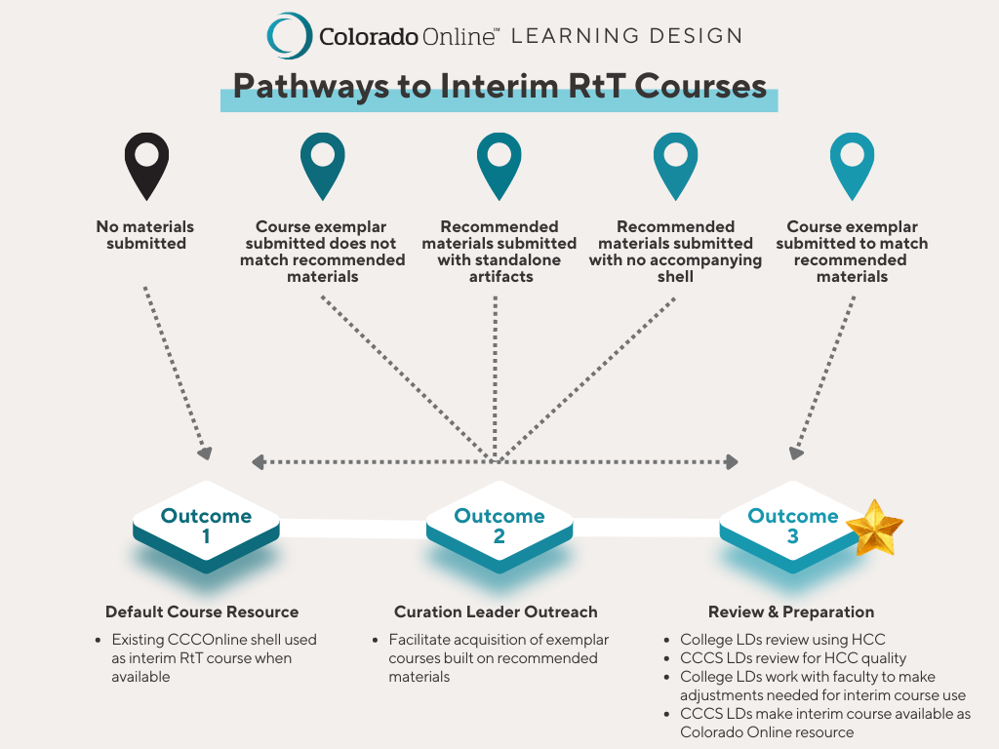Abbreviations
HCC = Healthy Course Checklist
LD = Learning Designer
RtT = Ready to Teach

Pathway Descriptions
Material Submission State by January 23 | Facilitated Collaboration | Outcome
If a course exemplar is submitted to match recommended materials . . . | Curation Leader Outreach  - Curation leader may reach out to discipline for single course selection agreement if multiple exemplars submitted | Review & Preparation  - College LDs review selected exemplar using HCC  - CCCS LDs collaborate with college LDs to review HCC quality  - College LDs work with faculty to make adjustments for interim RtT course use  - CCCS LDs make interim RtT course available as Colorado Online Resource
If recommended materials are submitted without an exemplar course . . . | Curation Leader Outreach  - Curation leader reaches out to discipline for exemplar course built around recommended materials  - Facilitate conversation toward single course selection if multiple exemplars submitted | If course provided:  Review & Preparation  - College LDs review selected exemplar using HCC  - CCCS LDs collaborate with college LDs to review HCC quality  - College LDs work with faculty to make adjustments for interim RtT course use  - CCCS LDs make interim RtT course available as Colorado Online Resource  If course not provided:  Default Course Resource  - Existing CCCOnline course shell used as interim RtT course resource when available
If recommended materials are submitted with standalone artifacts (e.g., assignments) . . . | Curation Leader Outreach  - Curation leader reaches out to discipline for complete exemplar course built around recommended materials  - Facilitate conversation toward single course selection if multiple exemplars submitted | If course provided:  Review & Preparation  - College LDs review selected exemplar using HCC  - CCCS LDs collaborate with college LDs to review HCC quality  - College LDs work with faculty to make adjustments for interim RtT course use  - CCCS LDs make interim RtT course available as Colorado Online Resource  If course not provided:  Default Course Resource  - Existing CCCOnline course shell used as interim RtT course resource when available
If a course exemplar is submitted that does not match recommended materials . . . | Curation Leader Outreach  Curation leader reaches out to discipline to determine whether:  - There is an exemplar course built around recommended materials  - The discipline agrees to adopt materials used in submitted exemplar course | If course provided or submitted exemplar course materials agreed upon:  Review & Preparation  - College LDs review selected exemplar using HCC  - CCCS LDs collaborate with college LDs to review HCC quality  - College LDs work with faculty to make adjustments for interim RtT course use  - CCCS LDs make interim RtT course available as Colorado Online Resource  If course not provided or submitted exemplar course materials not agreed upon:  Default Course Resource  - Existing CCCOnline course shell used as interim RtT course resource when available
If no materials are submitted . . . | Curation Leader Outreach  - Curation leader communicates default course resource outcome to discipline | Default Course Resource  - Existing CCCOnline course shell used as interim RtT course resource when available
Risk Factors
The following are strategic and performance risks related to the task of identifying and preparing interim RtT courses on a short timeline according to the proposed model.
- Timeline for discipline decisions on common materials may not create enough space to identify, review, and adjust corresponding exemplar courses prior to deadlines.
- Outcome 1 is only an option when an existing CCCOnline course shell is available. Where this is not the case, the interim RtT course shell or interim instructor resources for developing the online course must come from the CCCS colleges.
- Interim RtT courses (from colleges and/or CCCOnline) are unlikely to fully meet Healthy Course Checklist (HCC) criteria; need to prioritize quality criteria for course shell review and preparation (such as measurable outcomes, alignment, accessibility).

